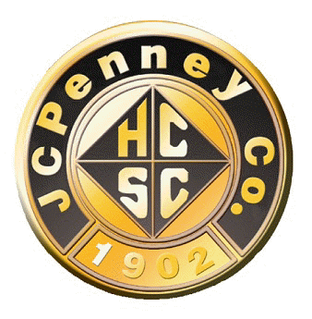
H.C.S.C. Golden Rule Award
for Community Service - Overview
-This will be an Annual Award beginning in 2024 recognizing HCSC Alumni Club members for service in their community.
-Nominations due April 15 of each year; RMG nominees announced June 1.
-One nominee recognized from each RMG and from National Only members.
-One National awardee selected by a committee comprised of HCSC National Board members.
-A consistent form will be provided for RMG Presidents to complete for their nominee with guidelines provided.
-Each RMG nominee and National nominee will be recognized by:
>Receiving $50.00 to donate to their charity (+$100 for the National awardee)
>Certificate (to be framed and presented by their RMG President at a local meeting or presented to a National Only member by the Executive Board)
>Partners Magazine recognition – Summer Edition article with pictures
>National Website recognition – Special link on the main landing page

