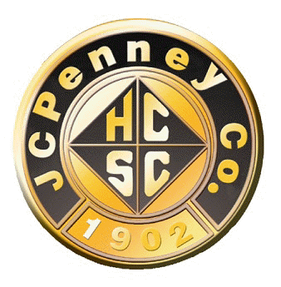
H.C.S.C. Golden Rule Award for Community Service Guidelines
-Each RMG President will encourage members to self-nominate for this award using the form provided prior to April 15 of each year. National Only members can self-nominate and email their nomination to the National HCSC Club President.
-The RMG President and local Board will select one applicant to be submitted as their RMG nominee.
-RMG President submits their nominee’s official form to the National Alumni Club President by April 15 via email nomination form, member’s nomination letter as an attachment and as a separate attachment a picture of their representative.
-A committee of National Board members will review each of the RMG nominee’s applications and National Only member applications and select one as the National award recipient by May 1st.
-The National award recipient and RMG nominees will be recognized in a National email to all members by May 15 and in the Partners Summer edition.
-The National award recipient and RMG nominees/National Only member nominee will receive their checks for their charities by June 1.
-RMG Presidents will receive certificates of appreciation via email attachment by June 1 for presentation to their RMG nominees. National Only members will receive their certificate of appreciation presented by Executive Board members.
-RMG nominees may be nominated more than once from year to year as long as their community service is current for each year.

