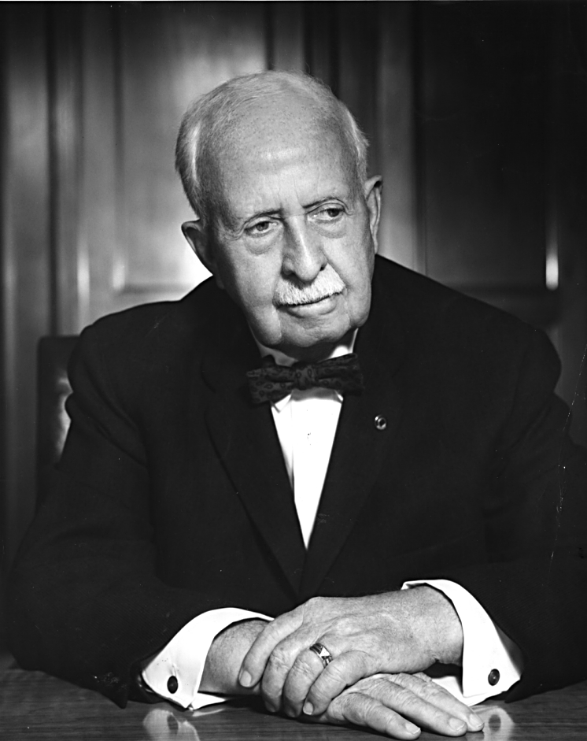
James Cash Penney
Library of books he has written or co-wrote!
Main Street Merchant (1948)
https://www.amazon.com/MAIN-STREET-MERCHANT-Penney-Company/dp/B00232P87S/ref=sr_1_1?crid=247JHORH1C2OQ&dib=eyJ2IjoiMSJ9.hTgMoAYOyZKw-5uebvC_pl1-WasFcedj7ur4xXPltEjEGHrJrKSdXM0wj1z55TrAO_j1xyxexONIgIsTqEmECzP_E6202htSraO8ccWjjliRL0GabJhRIe08qCkn2CMxBobdNjvbkDIapCkiIQqNVAGh4oZDKZ1RRG-xxSTVOrTkNdUUrJJVeHn7bYK7XCBQFRqHoSZK5M3dQBgsYUPC91bvEA4dXUFFm9ZKJK3ZgIo.ghxwBR3l7DSxpBl_zBMyIlOp2xA2C0QmrrE4xOxX6mo&dib_tag=se&keywords=Main+Street+Merchant+book&qid=1709932440&sprefix=main+street+merchant+book%2Caps%2C133&sr=8-1
My Experience with the Golden Rule (1949)
https://www.amazon.com/gp/product/1258335026/ref=ppx_yo_dt_b_search_asin_title?ie=UTF8&psc=1
50 Years with the Golden Rule (1950)
No longer being published. Considered a rare book if you can find it.
Lines of a Layman – The Golden Rule in Everyday Living (1956)
https://www.amazon.com/s?k=The+Golden+Rule+in+Every+Day+Living&crid=33YKA2C430KMA&sprefix=the+golden+rule+in+every+day+living%2Caps%2C131&ref=nb_sb_noss
View from the Ninth Decade (1960)
https://www.amazon.com/View-Ninth-Decade-J-Penney/dp/B0007DOG9Q

