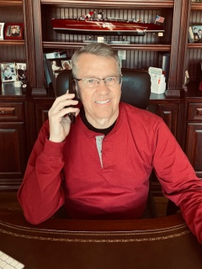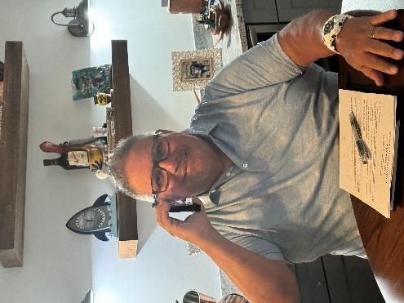

Phone an HCSC Friend Today and Catch Up!
Has it been a while since you talked to an old HCSC (JCP) Friend? Wouldn’t it be great to catch up with them?
Is there a member of your Regional Meeting Group in ill health? Wouldn’t it be great if you called and expressed your concern and care?
Do you know a Century Club member who is likely alone and would love to hear from another member that would “make their day?”
Don’t know how to contact your Friend? Use the HCSC Member Database at this link: https://jcphcscalumniclub.org/
It’s easy: 1) log in using your email and password
2) Enter the visual captcha code for authorization
3) Click on the “Search Members” box
4) Enter last name and first name of your Friend (be exact)
The HCSC Alumni Club is all about relationships! Take a few minutes to reach out and connect with other HCSC members and friends and catch up! You’ll enjoy re-establishing that great connection or building a new one!

