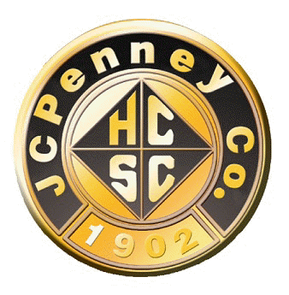
H.C.S.C. Golden Rule Award for Community Service
Nomination Form
Regional Meeting Group (if National Only Member leave blank):

Submitted by RMG President or RMG Board Member (If National Only Member leave blank):

RMG or National Only Member’s Name:

RMG or National Only Member’s Full Address (for check mailing):

RMG or National Only Member’s Application Requirements
-National Only members can self-nominate
-limit to 900 words or less on a separate word document including this information:
*Name of volunteer organization; type of volunteer work; annual number of hours; if multiple organizations volunteered for, select one to receive the check.
-please include member’s name on their separate word document
-please email this form, the separate letter of nomination word document, and a current picture of your RMG member or National Only member as attachments to the HCSC Alumni Club National President by April 15 or sooner. Nominations received after April 15 will not be accepted.
*Eligible volunteer organizations are limited to 501 © 3 charitable organizations. Political, social, and religious organizations are not eligible.

